L2 Managed Carrier Ethernet Fiber Switch
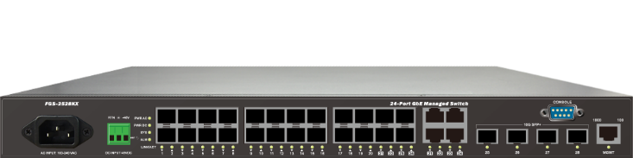
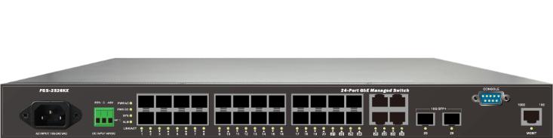
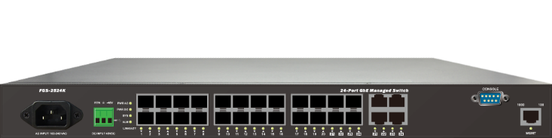

FGS-2524K

FGS-2526KX

FGS-2528KX

Overview
L2 Managed Carrier Ethernet Fiber Switches are a next-generation Carrier Ethernet NID offering full suite of L2 features and Carrier Ethernet features such as OAM, CFM, 1588v2 PTP and SyncE, etc., which delivers better cost performance and lower total cost of ownership in Enterprise networks via fiber or copper connections.
They are consists of FGS-2528KX, FGS-2526KX and FGS-2524K models with built-in AC or DC power supply. They provides high HW performance and environment flexibility in a compact form factor that facilitates desktop, wall-mount, or rack-mount installations for Carrier/Telecom providers.
The series are ideal for environments that require advanced features for granular control which is a must for easy network configuration and management where you need for a successful installation for high-bandwidth VoIP, Gigabit-to-the-Desktop deployments, converged voice and data networks in Carrier Ethernet Applications.
Key Features
- Carrier Ethernet features provide easier manageability, security, QoS
- IEEE 1588v2 PTP (TC)
- IEEE 802.3ah OAM
- IEEE 802.1ag CFM (ITU-T Y.1731 Performance monitoring)
- ITU-T G.8031 Ethernet Linear Protection Switching (EPS)
- ITU-T G.8032 Ethernet Ring Protection Switching (ERPS)
- IEEE 802.3az Energy Efficient Ethernet standard for green Ethernet application
Benefits
- Feature-rich Carrier Ethernet Switch for Metro Ethernet
The switch delivers advanced functionality in Carrier Ethernet switch including IEEE 1588v2, OAM, CFM, etc. It also enhanced security features such as IP source guard, Access Control List guard your network from unwanted or unauthorized access.
It helps users to build on the market-leading price/performance with Carrier Ethernet switch, and provide secure, reliable for metro Ethernet deployments.

- Exceptional Precision with IEEE 1588v2 (TC)
The switch performs IEEE1588v2, including transparent and boundary clock capabilities, implementations in hardware, so there is no performance penalty on packet processing.
The hardware architecture ensures low latency and high time accuracy – which is critical for delay-sensitive financial and mobile applications.

- Lower Total Cost of Ownership (TCO) with Energy-efficient Design
The switch is designed to help companies to save power needs and reduce TCO by Energy Efficient Ethernet (IEEE 802.3az). It can be used for customers to build a green Ethernet networking environment.
Specifications
Port Configuration
Model Name | Total Ports | RJ45  (100M/1G) | SFP  (100M/1G) | SFP+  (1G/10G) | RJ45/SFP  Combo | Combo  Port
FGS-2524K | 24 | -- | 20 | -- | 4 | DB9
FGS-2526KX | 26 | -- | 20 | 2 | 4 | DB9
FGS-2528KX | 28 | -- | 20 | 4 | 4 | DB9

Hardware Performance
Model Name | Forwarding Capacity (Mpps) | Switching  Capacity (Gbps) | Mac Table  (K) | Jumbo Frames  (bytes)
FGS-2524K | 35.712 | 48 | 32 | 10056
FGS-2526KX | 65.472 | 88 | 32 | 10056
FGS-2528KX | 95.232 | 128 | 32 | 10056

Environmental Range
Model Name | Operating Temperature |  | Storage Temperature |  | Altitude
Model Name | Fahrenheit | Centigrade | Fahrenheit | Centigrade | Feet | Meters
FGS-2524K | -4 to 140 | -20 to 60 | -13 to 158 | -25 to 70 | < 10000 | <3000
FGS-2526KX | -4 to 140 | -20 to 60 | -13 to 158 | -25 to 70 | < 10000 | <3000
FGS-2528KX | -4 to 140 | -20 to 60 | -13 to 158 | -25 to 70 | < 10000 | <3000

Dimension, Weights, Humidity
Model Name | Dimension (WxHxD) |  |  | Weight |  |  |  | Operating Humidity
Model Name | Millimeter |  | Inches | Kilograms |  | Pounds |  | Operating Humidity
FGS-2524K | 442 x 44 x 211 | 17.4 x 1.73 x 8.3 |  | 3.0 | 6.6 |  | 10% to 90% non-  condensing
FGS-2526KX | 442 x 44 x 211 | 17.4 x 1.73 x 8.3 |  | 3.1 | 6.8
FGS-2528KX | 442 x 44 x 211 | 17.4 x 1.73 x 8.3 |  | 3.1 | 6.8

Carrier Ethernet Features
Model Name | IEEE 1588v2 PTP | SyncE | ITU-T Y.1564  (RFC2544) | IEEE 802.3ah  OAM | IEEE 802.1ag  CFM | EPS | ERPS
FGS-2524K | TC | -- | -- | Y | Y | Y | Y
FGS-2526KX | TC | -- | -- | Y | Y | Y | Y
FGS-2528KX | TC | -- | -- | Y | Y | Y | Y

Voltage and Frequency
Input Voltage and Frequency
AC Voltage | 100-240 VAC
AC Frequency | 50-60 Hz
DC Voltage | 24-48 VDC

Certification
Electromagnetic Emissions (EMC)
CE, FCC Part 15 Class A
Software Features
Layer 2 Switching
Spanning Tree Protocol (STP) | - Standard Spanning Tree 802.1d  - Rapid Spanning Tree (RSTP) 802.1w  - Multiple Spanning Tree (MSTP) 802.1s
Trunking | Link Aggregation Control Protocol (LACP) IEEE 802.3ad  - Up to 14 groups  - Up to 4 ports per group
VLAN | Supports up to 4K VLANs simultaneously (out of 4096 VLAN IDs)  - Port-based VLAN  - 802.1Q tag-based VLAN  - MAC-based VLAN  - Management VLAN  - Private VLAN Edge (PVE)  - Q-in-Q (double tag) VLAN  - Voice VLAN  - GARP VLAN Registration Protocol (GVRP)
DHCP Relay | - Relay of DHCP traffic to DHCP server in different VLAN.  - Works with DHCP Option 82
IGMP v1/v2/v3 Snooping | IGMP limits bandwidth-intensive multicast traffic to only the requesters. Supports 1024 multicast groups
IGMP Querier | IGMP querier is used to support a Layer 2 multicast domain of snooping switches in the absence of a multicast router
IGMP Proxy | IGMP snooping with proxy reporting or report suppression actively filters IGMP packets in order to reduce load on the multicast router
MLD v1/v2 Snooping | Delivers IPv6 multicast packets only to the required receivers
Security
Secure Shell (SSH) | SSH secures Telnet traffic in or out of the switch, SSH v1 and v2 are supported
Secure Sockets Layer (SSL) | SSL encrypts the http traffic, allowing advanced secure access to the browser-based management GUI in the switch
IEEE 802.1X | - IEEE802.1X: RADIUS authentication, authorization and accounting, MD5 hash, guest VLAN, single/multiple host mode and single/multiple sessions  - Supports IGMP-RADIUS based 802.1X  - Dynamic VLAN assignment
Layer 2 Isolation Private VLAN Edge | PVE (also known as protected ports) provides L2 isolation between clients in the same VLAN. Supports multiple uplinks
Port Security | Locks MAC addresses to ports, and limits the number of learned MAC address
IP Source Guard | Prevents illegal IP address from accessing to specific port in the switch

Security
RADIUS/ TACACS+ | Supports RADIUS and TACACS+ authentication. Switch as a client
Storm Control | Prevents traffic on a LAN from being disrupted by a broadcast, multicast, or unicast storm on a port
DHCP Snooping | A feature acts as a firewall between untrusted hosts and trusted DHCP servers
ACLs | Supports up to 256 entries. Drop or rate limitation based on:  - Source and destination MAC, VLAN ID or IP address, protocol, port,  - Differentiated services code point (DSCP) / IP precedence  - TCP/ UDP source and destination ports  - 802.1p priority  - Ethernet type  - Internet Control Message Protocol (ICMP) packets  - TCP flag
Quality of Service
Hardware Queue | Supports 8 hardware queues
Scheduling | - Strict priority and weighted round-robin (WRR)  - Queue assignment based on DSCP and class of service
Classification | - Port based  - 802.1p VLAN priority based  - IPv4/IPv6 precedence / DSCP based  - Differentiated Services (DiffServ)  - Classification and re-marking ACLs
Rate Limiting | - Ingress policer  - Egress shaping and rate control  - Per port
Management
IEEE 1588v2 PTP | Supports IEEE 1588 v2 PTP (Precision Time Protocol) TC aware
Remote Monitoring (RMON) | Embedded RMON agent supports RMON groups 1,2,3,9 (history, statistics, alarms, and events) for enhanced traffic management, monitoring and analysis
Port Mirroring | Traffic on a port can be mirrored to another port for analysis with a network analyzer or RMON probe. Up to N-1 (N is Switch’s Ports) ports can be mirrored to single destination port. A single session is supported.
UPnP | The Universal Plug and Play Forum, an industry group of companies working to enable device-to-device interoperability by promoting Universal Plug and Play
s-Flow | The industry standard for monitoring high speed switched networks. It gives complete visibility into the use of networks enabling performance optimization, accounting/billing for usage, and defense against security threats
IEEE 802.1ab (LLDP) | - Used by network devices for advertising their identities, capabilities, and neighbors on an IEEE 802ab local area network  - Support LLDP-MED extensions

Management
Web GUI Interface | Built-in switch configuration utility for browser-based device configuration
CLI | For users to configure/manage switches in command line modes
Dual Image | Independent primary and secondary images for backup while upgrading
SNMP | SNMP version1, 2c and 3 with support for traps, and SNMP version 3 user-based security model (USM)
Firmware Upgrade | - Web browser upgrade (HTTP/ HTTPs) and TFTP  - Upgrade through console port as well
NTP | Network Time Protocol (NTP) is a networking protocol for clock synchronization between computer systems over packet-switched
Other Management | - HTTP/HTTPs; SSH  - DHCP Client/ DHCPv6 Client  - Cable Diagnostics  - Ping  - Syslog  - Telnet Client  - IPv6 Management
Ethernet OAM
IEEE 802.3ah Link OAM | Supports IEEE 802.3ah Ethernet OAM (Operations, Administration & Management)
IEEE 802.1ag & ITU-T Y.1731 Flow OAM | - Supports IEEE 802.1ag Ethernet CFM (Connectivity Fault Management)  - Supports ITU-T Y.1731 Performance Monitoring
Loop Protection
ITU-T G.8031 | Supports ITU-T G.8031 Ethernet Linear Protection
ITU-T G.8032 | Supports ITU-T G.8032 Ethernet Ring Protection Switching
Loop Detection | Supports Loop Detection and Protection

